SURESH

Power BI Session

Module 9

**Creating a Paginated Report**

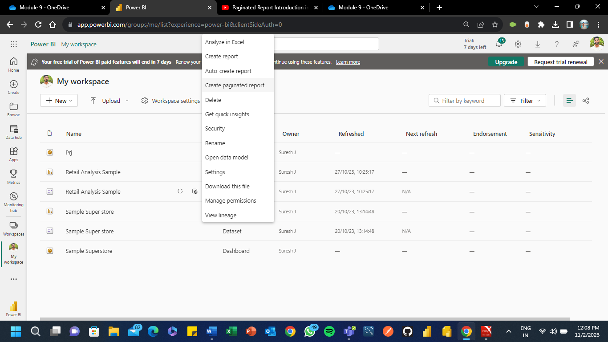

**Adding Columns**

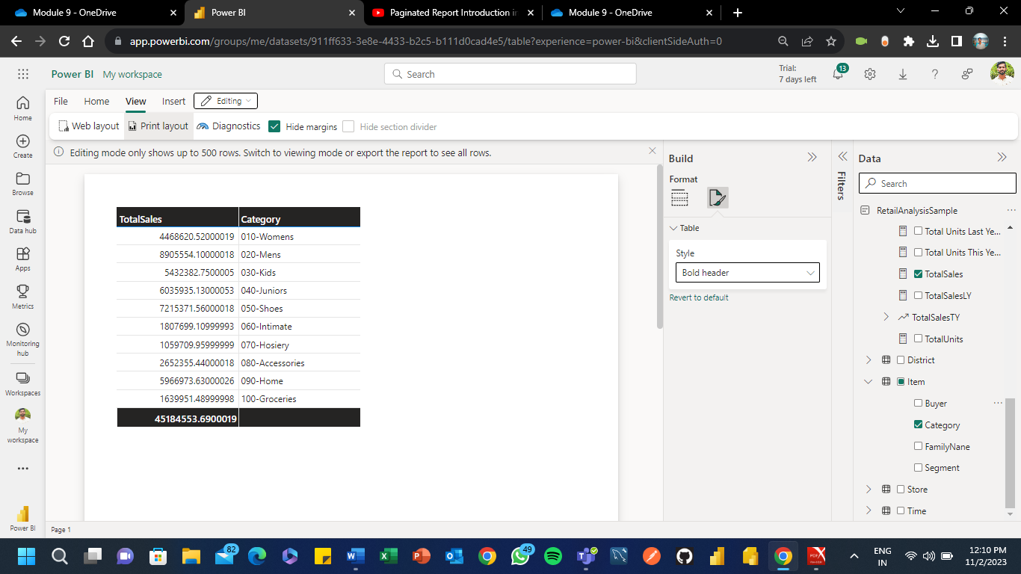

**Save and Download the Reports in .rdl format**

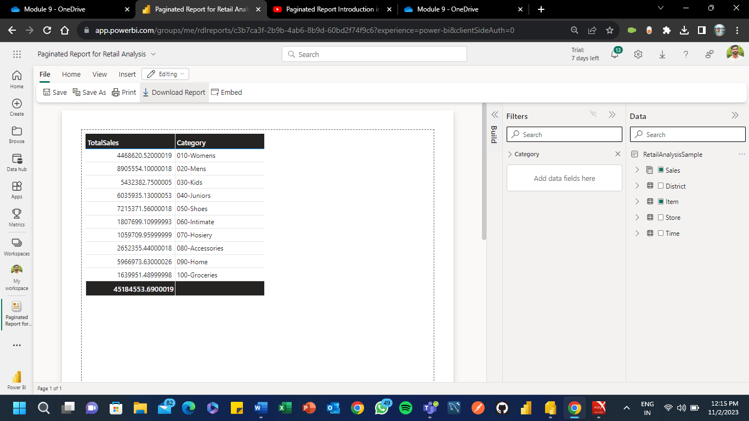

**Opening the .rdl file in Power BI Report Builder App**

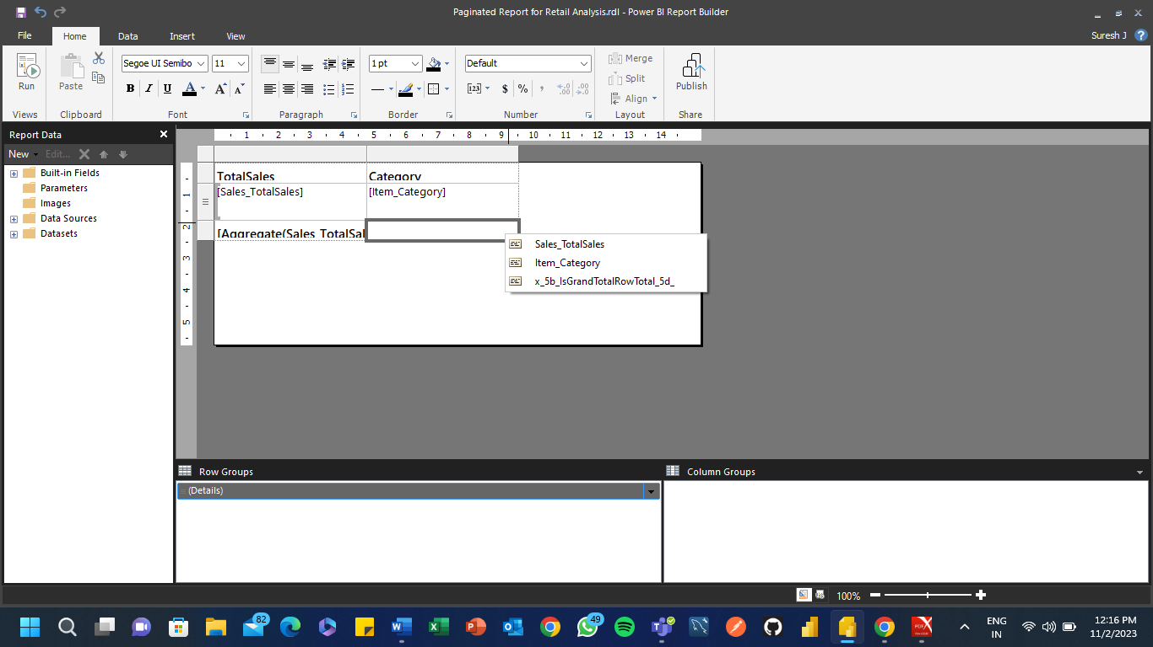

**Run and Viewing the Data which we Created**

